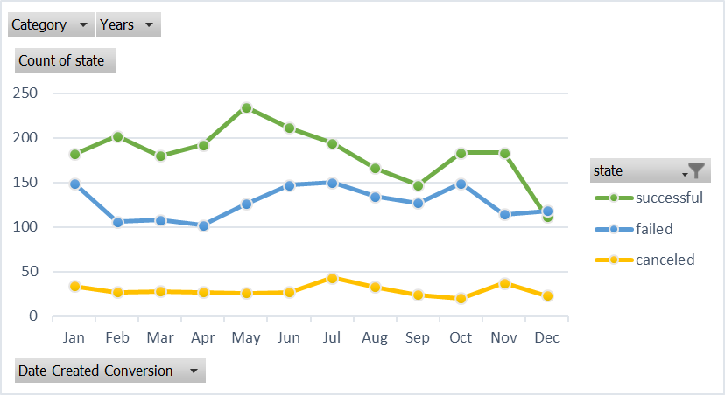

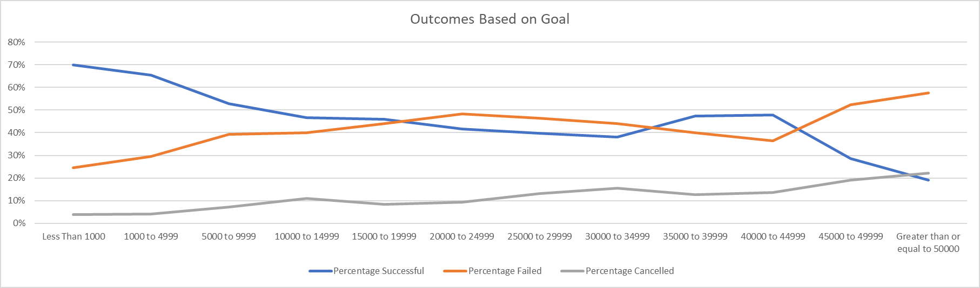

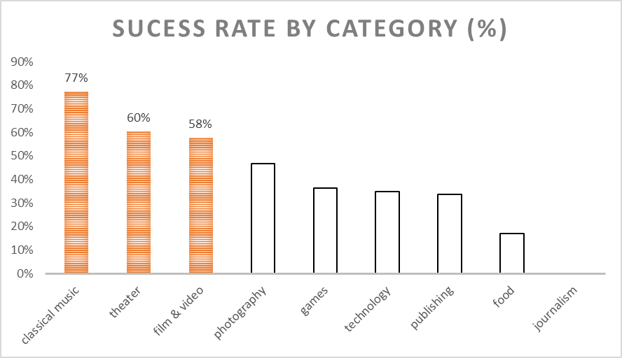

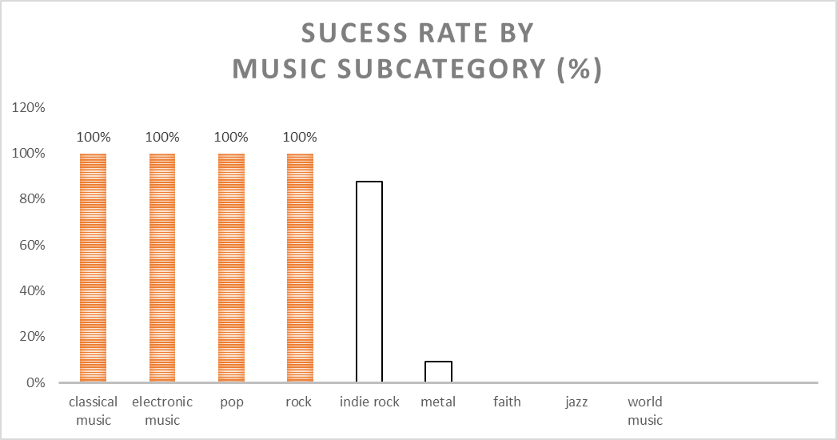

Conclusions:

* Projects are more likely to be successful when the campaign is started in May.
* Projects with a goal of less than $1000 have a significantly greater chance of being successful.
* Projects categorized under film & video, music, and theater have a greater likelihood of being successful.
* Projects under the sub-categories of classical music, electronic music, metal, pop, and rock tend will more than likely be successful.

Limitations:

* There is no glossary to define the column headers.
* There are no stated assumptions for the dataset.
* We’re only looking at a sample of the population from a certain time period.
* We do not know popularity or following of product or person prior to kickstarter campaign
* We do not know existing funding or investment of product prior to kickstarter campaign